CSE 5330 - DATABASE SYSTEMS

PROJECT 2: PART1 & 2

Enhanced Entity Relationship (EER) Diagram:

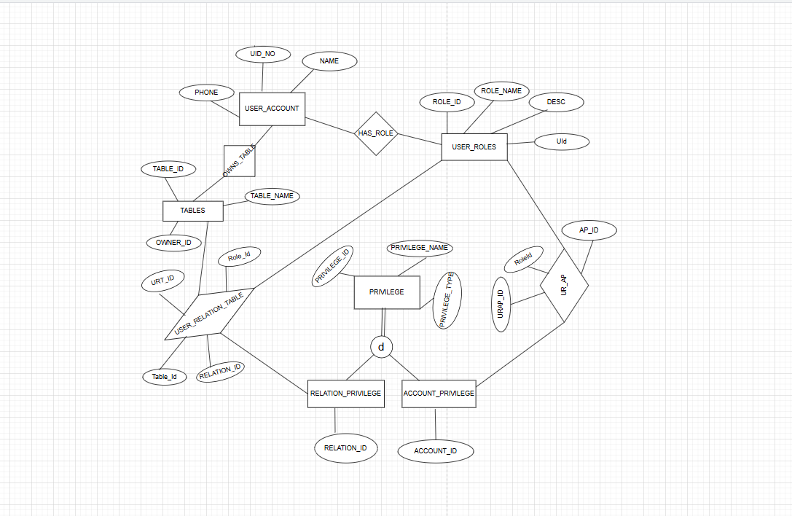

Design Choices:

In this EER diagram for the project 2,

1. The User Account Entity has attributes UID No, Name and Phone. In which UID No is the primary key.
2. That record in the user account is the owner of the table, Owner_ID in the table entity is the foreign key which references to user account entity. This binary relationship shows 1-to-many.
3. Allowing new privileges to be added at any time we have created a privilege entity with attributes Privilege ID, Privilege Name, privilege Type.
4. We have created two different entities, account privilege and relation privilege entities which are in disjoint relation to privilege entity.
5. The binary relationship between user roles and account privilege as one user role can have multiple privileges and one account privilege can be associated to multiple users so it’s many-to-many.
6. The ternary relationship between tables, user roles and relation privilege entity, creating a user_relation_table entity with attributes role_id and table id and relation id which are foreign keys referencing the three different entities.
7. There will be a many-to-many relationship across the three entities.

Assumptions:

1. The Table entity will have multiple tables but is related to a single account.
2. Each user role is related to exactly one user account.
3. Each privilege type in privilege entity is either related to relation privilege and account privilege.

EER to Relational Mapping Schema:

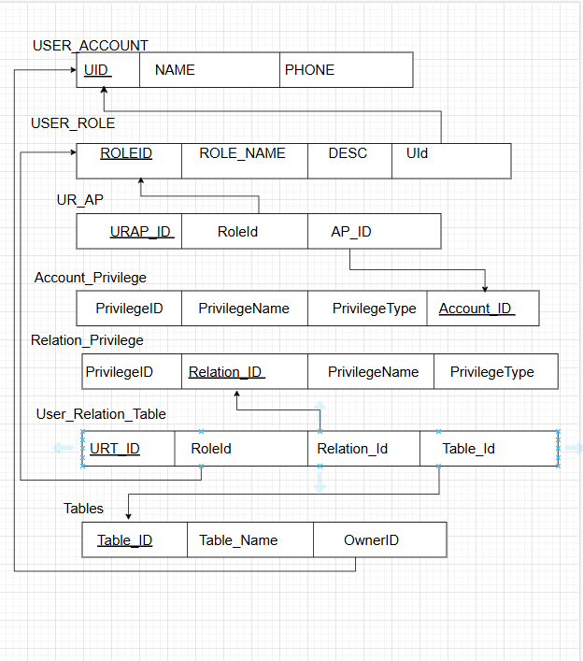

Choices:

1. All the Primary keys in the 7 entities from the enhanced entity relationship are underlined.
2. The entities account privilege and relation privilege are shown different from create tables. They are shown as mentioned in the example from the class modules because of their strict disjoint relationship with privilege entity.
3. The UR_AP forms a binary relationship between user role and account privilege.
4. The User_Relation_Table forms a ternary relationship between user role, relation privilege and tables entity.
5. All the foreign keys are represented by lined arrows to referenced entity.

Create Statements:

CREATE TABLE USER_ACCOUNT (

UID INT PRIMARY KEY,

Name VARCHAR(255) NOT NULL,

Phone VARCHAR(12) UNIQUE NOT NULL

);

CREATE TABLE TABLES (

TableID INT PRIMARY KEY,

TableName VARCHAR(255) NOT NULL,

OwnerID INT,

FOREIGN KEY (OwnerID) REFERENCES USER_ACCOUNT(UID)

);

CREATE TABLE USER_ROLES (

RoleID INT PRIMARY KEY,

RoleName VARCHAR(255) NOT NULL,

Role_desc VARCHAR(255),

UId INT NOT NULL,

FOREIGN KEY(UId) REFERENCES USER_ACCOUNT(UID)

);

CREATE TABLE PRIVILEGE (

PrivilegeID INT PRIMARY KEY,

PrivilegeName VARCHAR(255) NOT NULL,

PrivilegeType ENUM('Account', 'Relation') NOT NULL

);

CREATE TABLE ACCOUNT_PRIVILEGE (

Account_ID INT PRIMARY KEY AUTO_INCREMENT,

Privilege_Id INT,

FOREIGN KEY (Privilege_Id) REFERENCES PRIVILEGE(PrivilegeID)

);

CREATE TABLE UR_AP (

URAP_ID INT PRIMARY KEY AUTO_INCREMENT,

RoleId INT,

AP_ID INT,

FOREIGN KEY (RoleId) REFERENCES USER_ROLES(RoleId),

FOREIGN KEY (AP_ID) REFERENCES ACCOUNT_PRIVILEGE(Account_ID)

);

CREATE TABLE RELATION_PRIVILEGE (

Relation_ID INT PRIMARY KEY AUTO_INCREMENT,

Privilege_Id INT,

FOREIGN KEY (Privilege_Id) REFERENCES PRIVILEGE(PrivilegeID)

);

CREATE TABLE USER_RELATION_TABLE (

URT_ID INT PRIMARY KEY,

RoleId INT,

Relation_Id INT,

TableId INT,

FOREIGN KEY (RoleId) REFERENCES USER_ROLES(RoleID),

FOREIGN KEY (Relation_Id) REFERENCES RELATION_PRIVILEGE(Relation_ID),

FOREIGN KEY (TableId) REFERENCES TABLES(TableID)

);